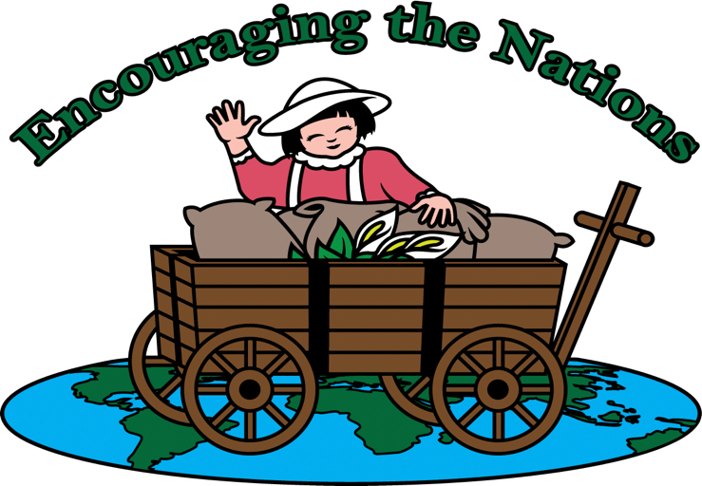

Logo for Encouraging the Nations

The logo for Encouraging the Nations demonstrates the vision for this ministry: Go north, south, east and west helping people to lift their burdens by encouraging and empowering them through the love of Christ.
The map represents Matthew 28: 19-21 where Jesus gave His disciples (including believers today as well) the Great Commission, telling them to make disciples of ALL nations.
The four wheels symbolize circles of love, which envelop people whom believers encounter when they answer the call to share the Gospel.
The wagon is filled with burlap bags representing the burdens of all people. On top of the burlap bags is a spotless, white flower symbolizing Jesus Christ as the Savior of the world. He expects His disciples to be His hands and feet, helping others to lift their burdens by encouraging and empowering them through His love.
The girl, standing behind the wagon, is dressed in red and white because she has surrendered her life to Jesus and accepted the greatest gift ever given, the gift of salvation. The handle of the wagon is in the shape of a cross, because Jesus shed His blood on the cross for whoever will believe on Him and ask Him to forgive his/her sins. The white represents righteousness or right standing with God with which God clothes those who invite Him to be their Lord and Savior.
The girl’s right hand is lifted in praise because with praise comes victory. Isaiah 61: 4 says that the Messiah will give us a garment of praise for the spirit of heaviness. Her left hand is lowered onto the burlap bags near the white flower, as she prays for the people, lifting their burdens to the Lord. When believers praise God, pray for others and extend His compassion, mercy and grace, He will lift the burdens of the people and turn them into blessings. This is the vision of my ministry for Encouraging the Nations—to make a difference in the lives of others—north, south, east and west, through the love of Christ.

