Endorsement

It only takes a God moment, a God divine appointment, to let you know that you have met someone special and someone God wants to use mightily to propel the Gospel around the world. When I first met Martha Dobson and her husband Ben, I knew that it was a God reason.
Our Kingdom building organization, The Stars Foundation, affords me unique and incredible opportunities to travel the world and see the plight of some of the most oppressed and afflicted people in the world. What can I personally do as a Kingdom worker for Jesus to make their lives better? That is my quest and my life vision. After seeing dead babies in trash cans, and young prostitutes as young as twelve in Thailand being abused by eighty-year-old men, I dedicated to make a difference.
What makes Martha Dobson’s book, Be Encouraged, so extraordinary is that she conveys through their testimonies that people everywhere are oppressed by Satan and his demons through forms of addictions, poverty, sickness, accidents, abuse, offense, bitterness, unforgiveness, family issues and other difficulties, but there is GOOD NEWS! The truth that stands out in the book is that our Lord is greater, our Lord is loving and merciful, and Jesus gives people hope, courage and inspiration! Readers will realize through the testimonies, that if THIS PERSON can overcome, then so can I! With the love of Jesus, we can do all things. I would encourage people to read this book and be a blessing as Martha is donating 100% of the proceeds to help build an orphanage in Uganda.
My husband Roger Piggott, the CEO of Iceman Productions, also endorses this book and shares the following testimonies of just a few of the many miracles that God has blessed him to witness or experience.

Cheryl Robeson Piggott
CEO of The Stars Foundation
Founder of World Orphans Day

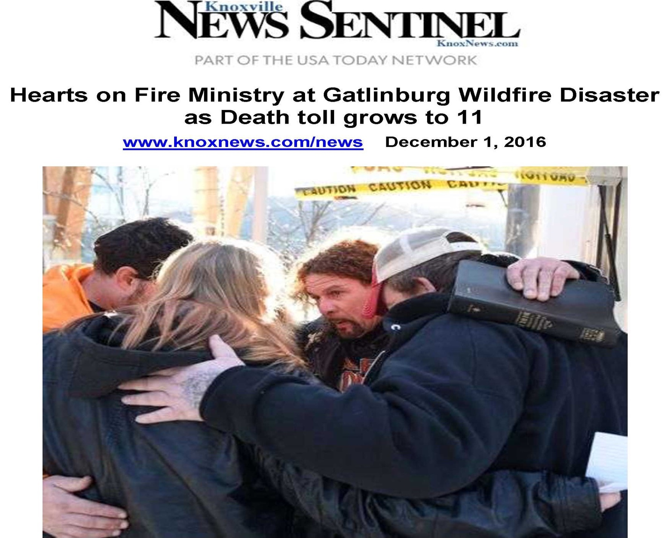
Miracle in Sturgis, North Dakota

NO MIRACLES HAPPEN WITHOUT AN ACTION

Roger Piggott, the CEO of Iceman Productions, had just completed filming a biker event for television when he left to ride his motorcycle twenty-seven hours to the Mount Rushmore Park in the Black Hills region of South Dakota where he met the crew he was to work with on a filming job. The Lord supernaturally strengthened Roger on this trip so that he felt as lively as if he had been able to have plenty of sleep. He was not drowsy, just as if he had flown. Philippians 4: 13 says, “I can do all things through Christ who strengthens me.” As Roger drove, God strengthened him, just as the scripture says. That was a miracle. The miracle happened as he continued to act, to drive.

NO MIRACLES HAPPEN WITHOUT AN ACTION

Roger had a four hour window open in the afternoon when he had no interviews. The Director of Photography wanted to film scenic sites with Roger on his motorcycle. The director showed Roger a back road in a very picturesque area between two mountains from where the Discovery Channel filmed.
The crew had a rental car on which they mounted cameras on the hood and the trunk in order to simulate motorcycles driving on the road. They had no walkie talkies. They wanted to film a shot that looked as if there were a motorcycle following Roger with Mount Rushmore in the background. Roger had to be one sixteenth of a mile behind the car.
One man in the car had a clipboard. When he held it out the window, it meant that I was supposed to begin filming. There had to be perfect synchronicity. They worked on a one-lane road for one and one half hours to get the perfect shot. During that time, no vehicle came, and they got the perfect shot.
Suddenly, another motorcycle carrying two people appeared about a foot away from where Roger and the car were. Where Roger was the road was straight with a gradual curve. When the other motorcycle rounded the corner, it went sideways and the two people with the bike fell off the twenty-five foot cliff. The men in the rental car filmed the action with their Go-Pro cameras as Roger drove into the dust of the car going over the cliff.
Immediately, Roger slid down the twenty-five foot cliff, getting scrapes on his body, to try to help. The bike was on top of the two people who were punk rockers on their way to a Grateful Dead Concert.

NO MIRACLES HAPPEN WITHOUT AN ACTION

God gave Roger supernatural strength to lift the full-sized Harley, full of gas. His arms, which were on the hot muffler, were getting burned. He smelled gas, and threw the Harley bike up the hill. As Roger took action and put his arms around the muffler and began to lift, God supernaturally strengthened him. Isaiah 40: 292-31 says:

He gives power to the weak, and to those who have no might, He increases strength.
Even the youths shall faint and be weary, and the young men shall utterly fall,
But those who wait on the Lord shall renew their strength;
They shall mount up with wings like eagles, they shall run and not be weary,
They shall walk and not faint.

Roger was wearing motorcycle boots, and his feet cramped in such an awkward position, yet God still strengthened him.

NO MIRACLES HAPPEN WITHOUT AN ACTION

Roger saw that the man was dead, and half of his head was gone. His head had hit a rock from where boulders had been cut. Roger straddled the man and prayed. Roger had nearly been killed going down the hill. As he was trying to decide how to get out, he noticed a handful of pine trees and began to make his way back to the ledge. Then the Holy Spirit whispered to him, “Go back to the bike.” He said, “But, Lord, I’ve seen enough.” But he obeyed the voice of the Holy Spirit and went back to the bike. Again, Roger, as tired and exhausted as he was, put action to his thoughts. Habakkuk 3: 19 says:

The Lord God is my strength; He will make my feet like deer’s feet, And He will
make me walk on my high hills. Indeed, God strengthened him as he went up and
down the hill.

NO MIRACLES HAPPEN WITHOUT AN ACTION

When he reached the bike he realized that the man’s girlfriend was underneath the man’s body. When his head had slammed the rock, they fell, and the bike had slid on top of them. She had profuse bleeding from her left leg where two toes were missing. Blood from his head injury had flowed out onto her. She was having convulsions. Roger took off his American flag bandana and used it as a tourniquet to tie off the bleeding from her toes. He was standing over her and trying to calm her down. Her trembling stopped. Because of the sun behind her, she couldn’t see Roger’s face. She was seeing Jesus. She gave Roger her mother’s name and phone number. Then she began having another convulsion. Roger had called the paramedics, and they were on their way. When they arrived, he began to go back up the hill.
Shortly. Roger who has curly hair heard a paramedic shout, “Hey, Curley, she’s not responding. We have her on a backboard. Straddle her and talk to her.” Roger went back to the woman and said, “Hey, Darling. It’s me again.” She began responding.
That night the sheriff came. Roger reconstructed the details of the accident. He told the sheriff that he had called the woman’s mother and given her the number on the side of the ambulance. The sheriff wanted to know if Roger had removed anything or seen any drugs. Roger finished up with the sheriff and later heard from the woman’s mother.
While the woman was in the hospital, she gave her heart to the Lord and turned from being an atheist to being a devout Christian. When I stood over her and tried to calm her, she saw Jesus in me in the shadows. Now every year on the anniversary of the accident, the woman’s mother calls me and says, “Thank you.”
One more time it took an action to have a miracle. Roger was obedient to the Holy Spirit’s voice to go back to the scene of the accident. As he continued to speak to the woman to calm her, God saved the woman’s physical life, and then in the hospital performed the greatest miracle of all—salvation. She came to know the truth of John 3: 16:

For God so loved the world that He gave His only begotten Son, that whosoever
believeth in Him should not perish but have everlasting life.

Now she has everlasting life, the greatest gift ever!

NO MIRACLES HAPPEN WITHOUT AN ACTION

Note: This testimony including the picture is used with permission from Roger Piggott by telephone.

Touched by an Angel

Roger Piggott was five years old when his father left and his mother began to raise him alone. She and his aunt who was a Roman Catholic minister in the Bronx in New York, continually prayed for him and preached the Bible, yet he was considered to be the black sheep of the family. Most of his friends were not saved. He was running with an undesirable crowd.
Roger’s world turned around suddenly when his mother was diagnosed with stage four abdominal cancer. Palliative care was at the family household, and Roger knew that the state of his mother’s health meant that it would only be a matter of time until she would pass away.
Feeling abandoned and alone, Roger continued to pray for a miracle. His mother and grandmother continued to pray for him. Occasionally, his mother would wake up from the heavy drugs she was being administered and talk with him about turning a page in his life and giving himself to the Lord. Sometimes they would have discussions. While his mother slept, his personal pain for what he knew was going to happen would often lead him to read the Bible and pray. On one of these occasions, an angel appeared to him and said, “Roger, your mother is going to a place of rest where all things will be made new.” This experience took the personal hurt out of Roger’s mind immediately, and he started to pray for the Lord to take her and to help him to be what his mother and grandmother had prayed for.
Indeed, her health did decline quickly, and within four months she was gone. When she passed, Roger headed up the funeral service. While he was speaking to the people, he talked about Jesus and his mother going to a better place where all things are made new. After the service, many people asked him, “Where did you learn to preach? Did you go to seminary? “ This was the turning point of his life. God set him free from his cocaine addiction. He quickly became a member of a church. He was heavily involved with men’s group programming, specializing in troubled men and youth who have major forms of addiction, just as those with which he had struggled.
Now Roger lives his life for the Lord in every area of his life, especially in his vocation as an international television producer for sports programming, supplying fifty countries with regularly aired programming. He uses this television medium as an opportunity to minister to a secular television audience by placing Jesus Christ Saves and John 3:16 signage and advertising content into each of the television shows he produces. To date, he has produced 550 different episodes in worldwide circulation, and there is no turning back.
Roger lives his life as an example of what God can do in one’s life. This has taken him into Salvation Army Drug Rehab centers where he ministers to the afflicted. At church he prophesies and works with men, teaching them how Christ expects them to live as the head of the family. He also works with the military in the USA with an annual major event titled Rolling Thunder in Washington, D.C., which draws over one million participants. He was honored and blessed to be the chaplain for the Rolling Thunder Flame of Freedom motorcycle ride with the Nashville celebrities with whom he works as support to God’s army. He targets and ministers to the afflicted veterans in a rough crowd where people have low incomes, which he has experienced.
He has participated in high level spiritual training sessions with his church and has been used of God to save many from suicide. He relocated the Toronto Promise Keepers event from a church to a large sports facility and oversaw the transition in production. He is a motorcycle enthusiast who participates in the Ride for Christ and does many public appearances as a chaplain preaching the word of God.
He is happily married to Cheryl Piggott, with whom he is a warrior for Christ. Roger’s favorite scripture is Ephesians 6: 10-18, and the license plate on his bike is EP610. Most importantly, Roger is one of those individuals the evil one warns his demonic forces about, as he is willing, able and does continually take the hit for Jesus who is his Lord and Savior. His life is all about Jesus Christ.

Hearts on Fire Ministry at the Tennessee Wildfire
God Still Protects and Speaks to His People Today

One Tuesday Roger’s wife Cheryl called him panicking because the Tennessee wildfire had broken out. She asked him where he was. He said, “I’m in the television studio doing audio and finishing off an assignment behind Dollywood.
She told him that the fire was all around him, and that a mandatory evacuation had been done four hours earlier. I told the men with whom I was working that we had to get out of there. This was about 9:00 p.m.
I went outside, and there was fire all around me. You couldn’t see anything, not even your hands in front of you, due to the smoke. The men I was with wanted me to ride with them in their SUVs, but I did not want to leave my Harley bike behind. I got on my bike but couldn’t get out of first gear. The men were long gone. Both sides of the mountain road were fully engulfed. Cabins were engulfed with flames. I couldn’t go more than five miles per hour. I was wearing leather and was very hot. I was waiting for my windshield to melt and for my bike to explode with a full tank of gas. Steel melts at 2300 degrees. When I went back the next day, there was more melted steel than I could imagine, but I got out. The police that closed the road were just freaked out and said they thought they had heard a Harley. They said, “Boy, are you lucky!”
That night God spoke to him and told him to go to the relief ministry at
7:00 a.m. He obeyed God, but the members of the Red Cross who were in charge said that they don’t offer pastoral ministry. So he prayed and said, “O.K., God, I did what you said. You got me out of the fire, and I’m here. Now they say that they don’t offer pastoral ministry. What shall I do? He said, “Do what you do best.” What I do best is street ministry. Outside there were babies crying, children in pajamas and people screaming. The place was swamped. When a disaster happens, the officials in charge don’t give people the chance to get photo albums or other things. Many people lost their house and their lives. They just get you out.
Then I prayed and said to God, “Let me be of value to the people out here.”
I started praying with one person and one family with children. There were so many people wanting prayer that I made a huge circle of maybe forty to fifty people at a time to pray for people for calmness, peace, joy and hope. Hope is a big part of things because no one can have peace, joy or hope without the love of Jesus Christ. This is what Roger displays so well to afflicted people. He must have prayed for 300-350 people and families. He was there for around six hours.
There was a camera guy in the background with one of the newspapers. He asked me what book I was carrying. I said, “Oh, that’s the operations manual. Some people call it the Holy Bible.” On Thursday on the cover of USA Today, there was a story about me with my picture. I was dressed in my Harley clothes with my Bible in my hands and my arm around someone’s shoulder, praying. One pastor died in the fire. In one building alone 25 people died. There was so much sadness; yet, in the midst of the chaos and tragedy, God is still so……..good and
so…………faithful.

